

SAVEETHA SCHOOL OF ENGINEERING

SAVEETHA INSTITUTE OF MEDICAL AND
TECHNICAL SCIENCES

DEPARTMENT OF COMPUTER SCIENCE AND ENGINEERING

LIST OF EXPERIMENTS

COURSE CODE : CSA4001
COURSE NAME : MANAGEMENT INFORMATION SYSTEM

3 Make an Online Airline Reservation System. The activities of the Online Airline Reservation system are listed below user, admin, LOGIN, MANANGE CLASSES, MANANGE WAITING LIST, MANAGE HOLDS, MANAGE DEADLINES, LOGOUT, using this has a step-by-step process draw a CLASS diagram.

AIM:
To design a UML Class Diagram for an Online Airline Reservation System, illustrating the relationships between users, administrators, and system functionalities.

PROCEDURE:
• User and Admin Authentication
- Users and admins log in to the system using credentials.
• Manage Classes
- Admins can configure and manage different flight classes (Economy, Business, First Class).
• Manage Waiting List
- Users can be added to a waiting list if seats are unavailable.
- Admins can update or clear the waiting list.
• Manage Holds
- Temporary holds can be placed on reservations before confirmation.
• Manage Deadlines
- The system tracks booking deadlines, cancellations, and payment deadlines.
• Logout
- Users and admins can securely log out after completing actions.

OBSERVATION:

USECASE DIAGRAM:
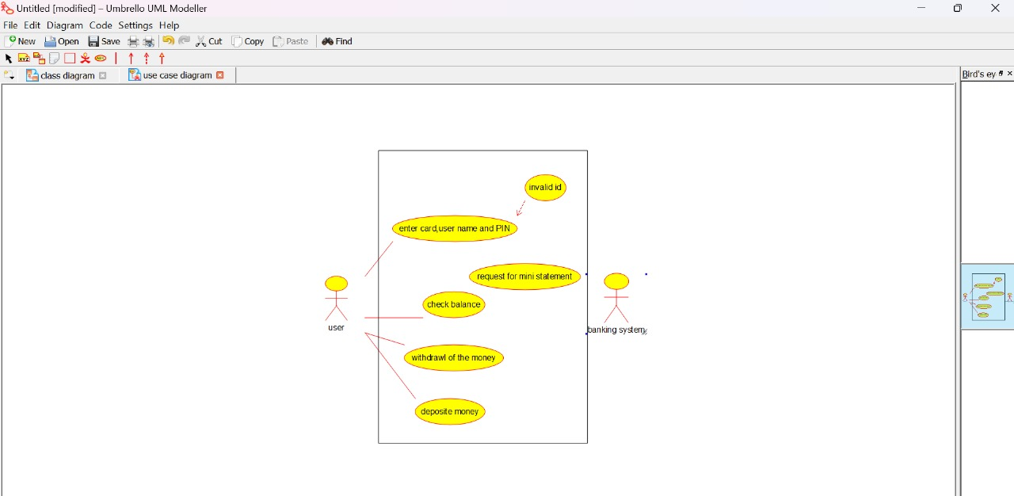

CLASS DIAGRAM:
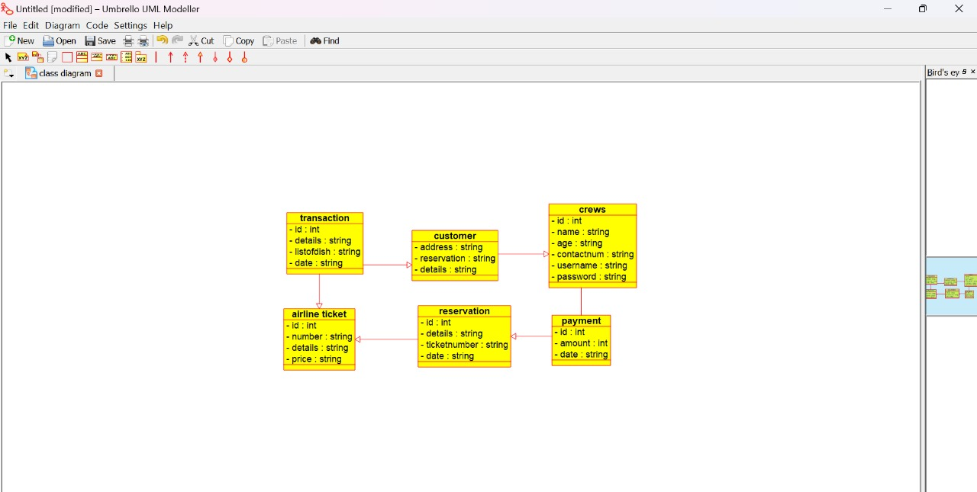

ACTIVITY DIAGRAM:
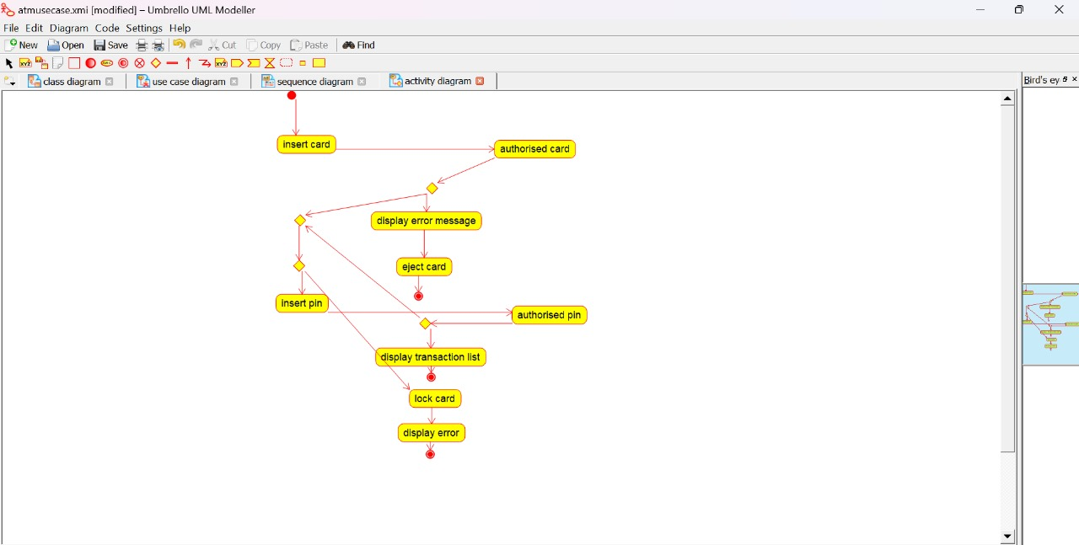

STATE DIAGRAM:
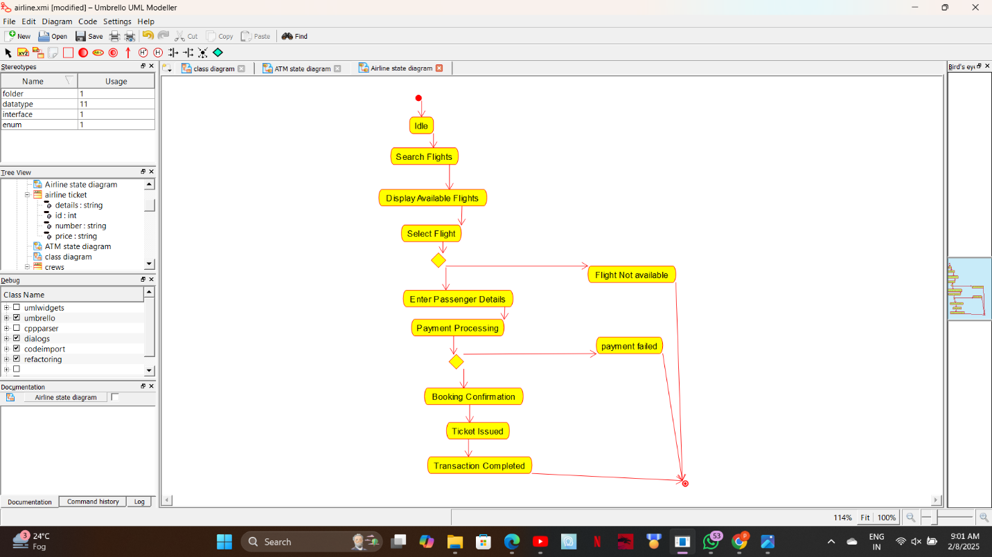

COLLABORATION DIAGRAM:
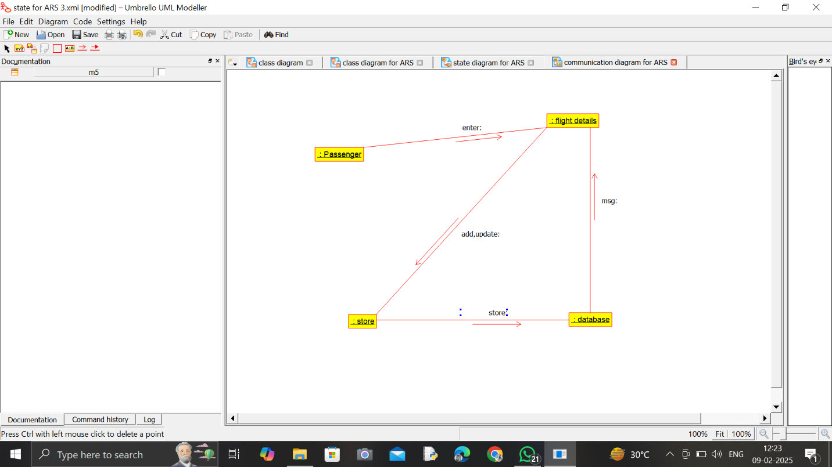

SEQUENCE DIAGRAM:
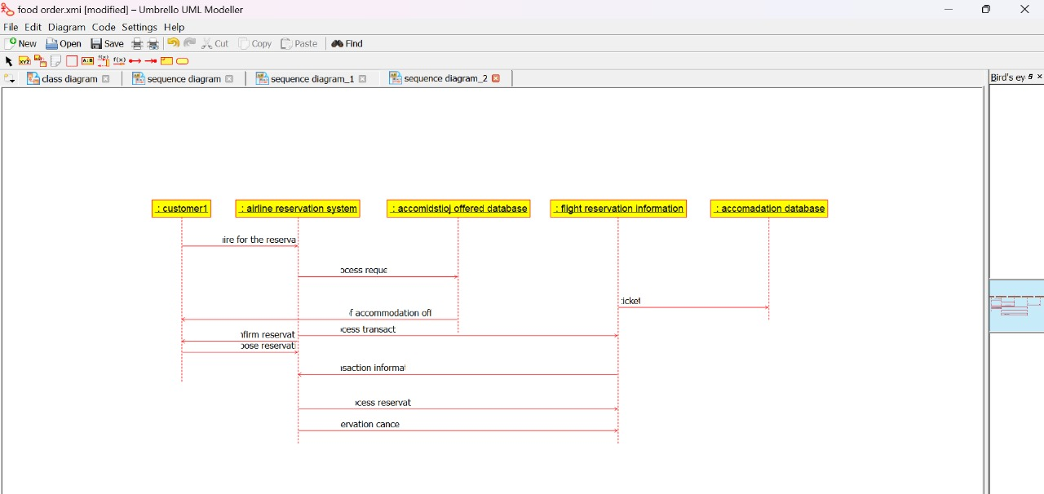

COMPONENT DIAGRAM:
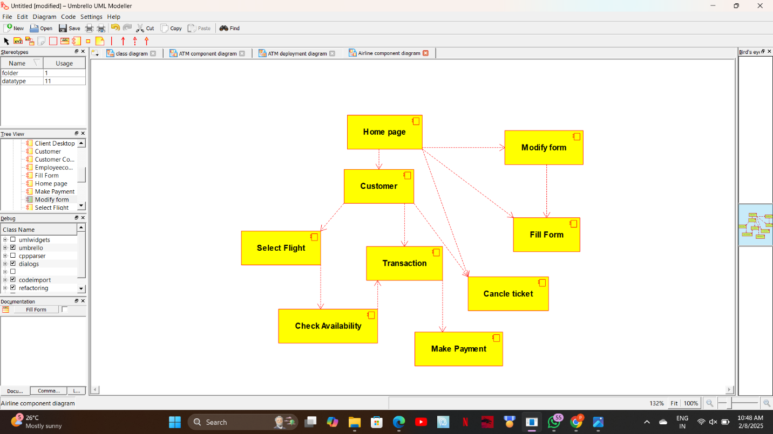

DEPLOYMENT DIAGRAM:
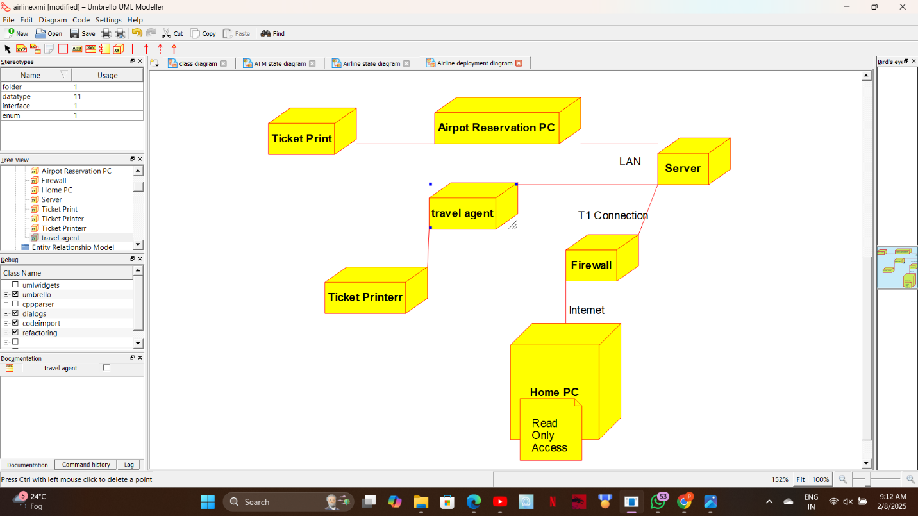

ER DIAGRAM:
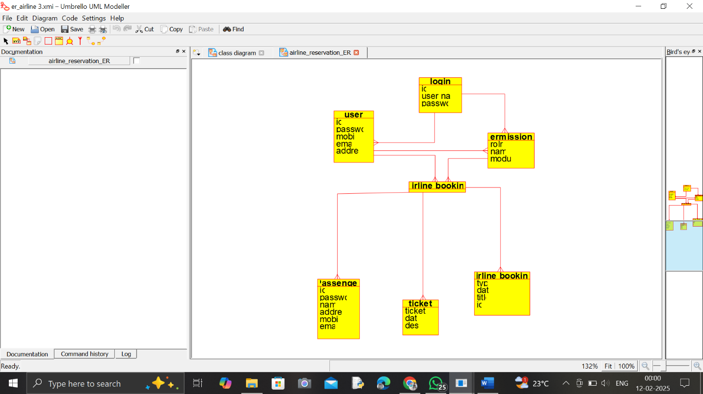

RESULT:

The UML Diagram for the Online Airline Reservation System has been successfully created, representing the structure and interactions between User, Admin, and system management functionalities.

